

**Rocco Forte St. Petersburg**

**Hoteza**

**Proposal**

Sergei Prokhorov

**Chief Engineer**



**Presented by:**

Nikolay Beloshitsky

**General Manager / SMARTEQ**

**SMARTEQ LLC**  
St. Petersburg

15A Novolitovskaya Str., of. 510,

St. Petersburg, 194100, Russia

Tel./fax: +7 (812) 640 2447

E-mail: nb@smarteq.ru

Proposal Valid to:  
**30.11.2016**

Proposal Issued:

**05.10.2016**

**Presented to:**

Trouble-Free Operation

PlatfromMultilingual

Single CMS for All Products

Hoteza Management System is the software that manages the whole range of Hoteza products: Hoteza TV, Hoteza HSIA, Hoteza Mobile, Hoteza HotSign, Hoteza Lobby. CMS has an intuitive and easy-to-use interface and powerful communications management application based in the cloud.

We provide a service “don’t call us, we’ll call you” – via remote online monitoring, Hoteza is aware of software and hardware problems before your in-room guest. Via Service Level Agreements (SLA) we make a commitment to all of our customers. These clearly defined actions and response times are easily measurable.

**Hoteza Main Advantages**

900+ hotels across the globe are SMARTEQ customers. This list also includes hotels of international hotel chains (Rezidor, Marriott, IHG, Hilton, Starwood, Hyatt, Four Seasons and others).

900+

**Statistics**

**1. Overview**

**SMARTEQ** is a trusted partner with enthusiastic people that delivers smart solutions to continually improve the hospitality industry and the experience of travelling. We are consistently leading technology development and empowering customers through the provision of guest-centric tools, allowing the hoteliers to keep in instant touch with their guests – before, during and after their stay in the hotel.

We create smart solutions for an even better hospitality experience. That is our mission, to ensure that your interactive needs are met – from boutique hotels to major chains. For the hospitality industry, Hoteza offers guest-centric services such as premium HSIA and IPTV systems, mobile applications, interactive lobby solutions and innovative digital signage system to provide information, way-finding and advertising to wide audiences.

**2. Hoteza Solutions Range**

Hoteza puts all your hotel’s information and services on one easy-to-use application, available through different channels:  in-room TVs, in-room tablets and guests’ own devices.  All systems – Hoteza IPTV, Hoteza Mobile, Hoteza Lobby, Hoteza HotSign and Hoteza HSIA are managed through a single cloud-based back-end (Hoteza CMS) that may be accessed and operated from any point of the world.

|  |  |
| --- | --- |
| **HOTEZA MOBILE APPLICATION**  An application for smartphones and tablets allowing your guests to use the hotel services in an easy and fast way without having to call or ask reception. |  |
|  | **HOTEZA IPTV**  A set-top box free IPTV system that runs on Smart TVs. Commitment to the HTML5 standard allows to provide all the benefits of Hoteza system, including interaction with smartphones and tablets. |
| **HOTEZA HOTPAD**  A multilingual guest services application designed for a room-based tablet and allowing guests to access and interact with the complete range of facilities and services on offer at your hotel. |  |
|  | **HOTEZA HSIA**  Hoteza HSIA provides easy to use high-speed Internet access, which is available to residents and guests of the hotel as well as restaurants and bars guests. |
| **HOTEZA LOBBY**  User-friendly touch screen usually placed in a lobby or a reception area that makes an effective marketing tool providing all hotel information along with all surroundings information your guests need. |  |
|  | **HOTEZA HOTSIGN**  Strategically placed screens that display both images and full HD video are an excellent solution for presenting hotel services, business conference information, airport departure/arrival lists, weather forecats,... |

**INTEGRATIONS**

|  |  |  |  |  |  |  |  |  |  |
| --- | --- | --- | --- | --- | --- | --- | --- | --- | --- |
| Leading Property Management Systems (PMS), Room Management Systems (RMS), SOS and other solutions integrate seamlessly into Hoteza soutions.   |  |  |  | | --- | --- | --- | | Картинки по запросу protel hotel software logo | Картинки по запросу oracle micros | Картинки по запросу hdl automation logo | |  |  |  | | Картинки по запросу lg business logo | Картинки по запросу samsung logo  Картинки по запросу facility slovenia logo | Картинки по запросу philips logo |   Картинки по запросу pressreader logo |

Notes:

*1* This proposal includes all installation costs

2 Hardware onsite delivery is included

3 Payment terms: 70% - advance payment, 25% - prior to delivery to the hotel, 5% - after signing handover documents

4 Proposal valid provided that RUB/USD rate is below 80,00 at the date of contract signing

Total Hoteza TV system with installation: 4 676 700.00

Discount for Rocco Forte: 2 000 000.00

TOTAL HOTEZA IPTV WITH DISCOUNT: 1 676 700.00

TOTAL HOTEZA IPTV + ТV’s: 14 295 870.00

Installation services

|  |  |  |  |
| --- | --- | --- | --- |
|  | Unit Price | Quantity | Total Amount |
| ► Hoteza TV server installation | **100 000,00** | **1** | **100 000.00** |
| ► TVsets installation and programming | **500,00** | **389** | **194 500.00** |
| ► Staff training |  | **1** | **included** |
| **ИТОГО:** | | | **294 500.00** |

LG hotel TVsets

|  |  |  |  |
| --- | --- | --- | --- |
|  | Unit Price | Quantity | Total Amount |
| ► Hotel LED TV LG 32LW641H | **23 910,00** | **18** | **430 380,00** |
| ► Hotel LED TV LG 43LW641H | **31 890,00** | **347** | **11 065 830,00** |
| ► Hotel LED TV LG 49UW761H | **46 790,00** | **24** | **1 122 960,00** |
| ► Hotel LED TV LG 55UW761H | **64 330,00** |  |  |
| **TOTAL:** | | | **12 619 170.00** |

**3. Commercial Proposal**

**Hoteza TV**

All prices listed below are in Roubles, VAT 18% included

Hoteza IPTV Server and Licences

|  |  |  |  |
| --- | --- | --- | --- |
|  | Unit Price | Quantity | Total Amount |
| ► **Hoteza IPTV Server**, including licences | **450 000,00** | **1** | **450 000.00** |
| ► **Hoteza TV Pro Licences**, including features below | **7 800,00** | **389** | **3 034 200,00** |
| - Welcome message |  | **389** |  |
| - Hotel information |  | **389** |  |
| - Photogallery |  | **389** |  |
| - Interactive services (in-room dining, shopping, wake-up call, etc.) |  | **389** |  |
| - Guest messages |  | **389** |  |
| - Full HD support |  | **389** |  |
| - PMS Link (Protel PMS) |  | **389** |  |
| - Channel List |  | **389** |  |
| - Guide |  | **389** |  |
| - Multilingual support |  | **389** |  |
| - Remote TV management |  | **389** |  |
| - Statistics Module |  | **389** |  |
| - Guest devices screen mirroring (Miracast) |  | **389** |  |
| - Promo channel(s) |  | **389** |  |
| - TV control by guest’s own mobile device |  | **389** |  |
| - Customized design |  | **389** |  |
| ► **Hoteza Mobile app** | **Complimentary** | **1** | **Complimentary** |
|  |  | **TOTAL:** | **3 484 200.00** |

LG hotel TVsets

|  |  |  |  |
| --- | --- | --- | --- |
|  | Unit Price | Quantity | Total Amount |
| ► Hotel LED TV LG 32LW641H | **23 910,00** | **18** | **430 380,00** |
| ► Hotel LED TV LG 43LW641H | **31 890,00** | **347** | **11 065 830,00** |
| ► Hotel LED TV LG 49UW761H | **46 790,00** | **24** | **1 122 960,00** |
| ► Hotel LED TV LG 55UW761H | **64 330,00** |  |  |
| **TOTAL:** | | | **12 619 170.00** |

Installation services

|  |  |  |  |
| --- | --- | --- | --- |
|  | Unit Price | Quantity | Total Amount |
| ► Hoteza TV server installation | **220 000,00** | **1** | **220 000.00** |
| ► TVsets installation and programming | **2 500,00** | **389** | **972 500.00** |
| ► Staff training (3 days session for Reception, F&В, Sales & Marketing, IT, Engineering, Banqueting & Events departments) |  | **1** | **included** |
| **TOTAL:** | | | **1 192 500.00** |

Optional services

|  |  |  |  |
| --- | --- | --- | --- |
|  | Unit Price | Quantity | Total Amount |
| ► VDA Micromaster GRMS integration | **350 000,00** | **1** | **350 000.00** |
| **TOTAL:** | | | **350 000.00** |

Total Hoteza TV system with installation: 4 676 700.00

TOTAL HOTEZA IPTV + ТV’s: 17 295 870.00

OPEX – 24/7/365 support monthly fees

|  |  |  |  |
| --- | --- | --- | --- |
|  | Per TV per month | TVs Number | Amount per month |
| ► Monthly support fees, including 24/7/365 hot line | **175,00** | **389** | **68 075.00** |

Notes:

*1* This proposal includes all installation costs

2 Hardware onsite delivery is included

3 Payment terms: 70% - advance payment, 25% - prior to delivery to the hotel, 5% - after signing handover documents

4 Proposal valid provided that RUB/USD rate is below 80,00 at the date of contract signing

5 Deployment time – 8 weeks including integration with VDA Micromaster GRMS

6 Special discount of 30% to be applied for any additional Hoteza solutions (HotPad, Digital Signage, Lobby, HSIA)

**4. TV System Designs**

Hoteza TV provides a choice of Guest User Interface templates – Regular (menu on the left side) and Metro (square blocks). Both design are customizable in terms of colors, fonts, background pictures, etc.

**Regular Design**

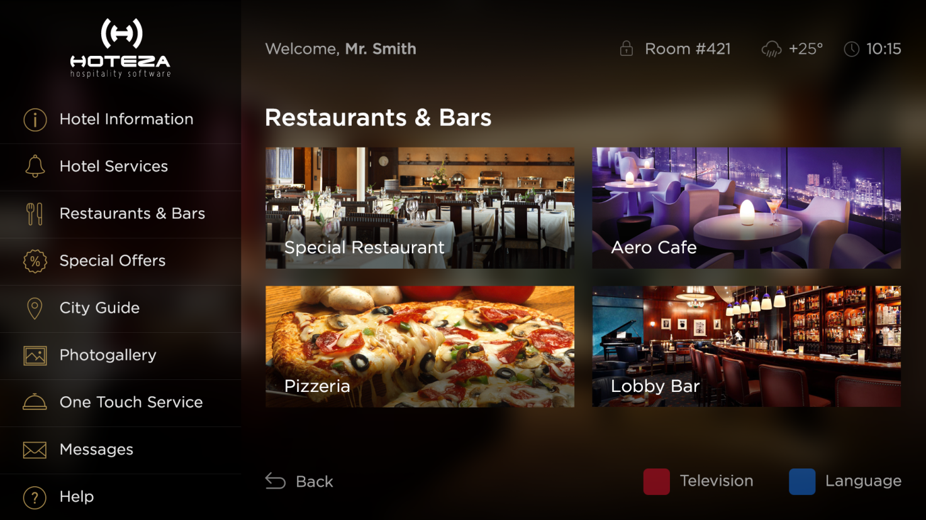

**Picture 1.** Hoteza TV regular design – Categories selection

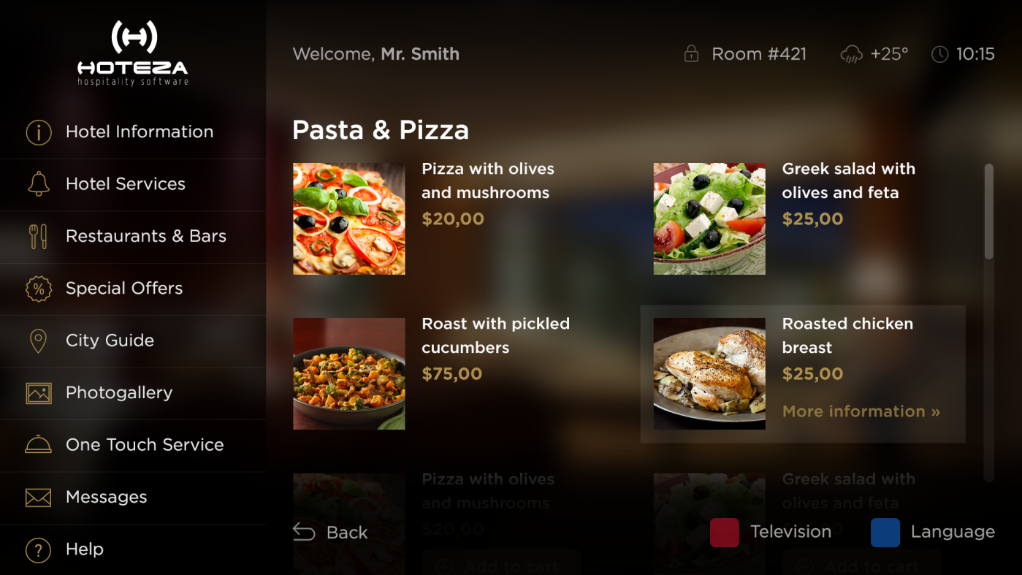

**Picture 2.** Hoteza TV regular design – In-room dining selection

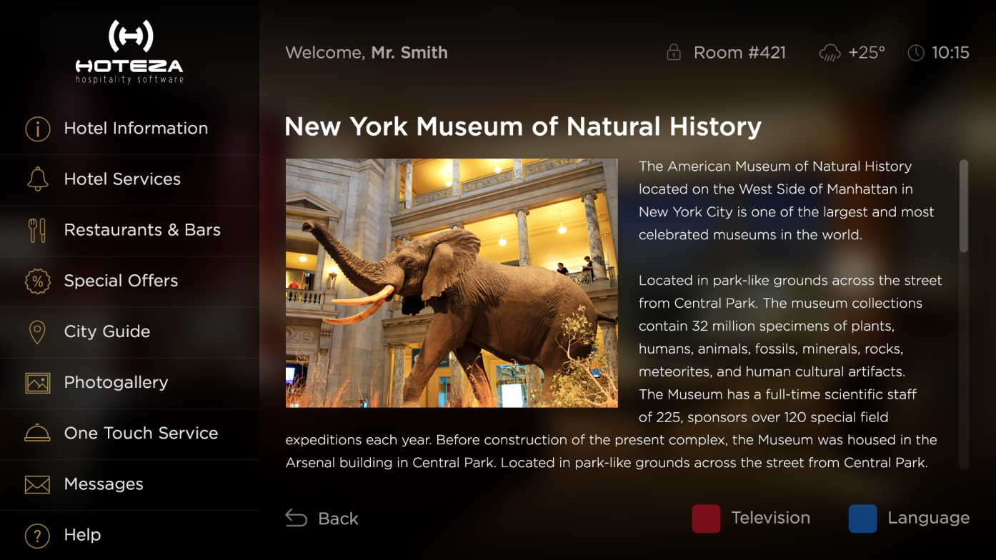

**Picture 3.** Hoteza TV regular design – Information page

**Metro Design**

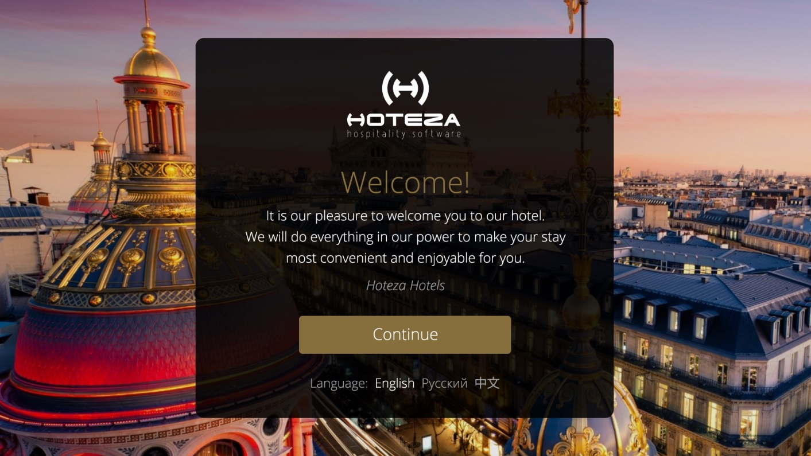

**Picture 4.** Hoteza TV metro design – Welcome Screen

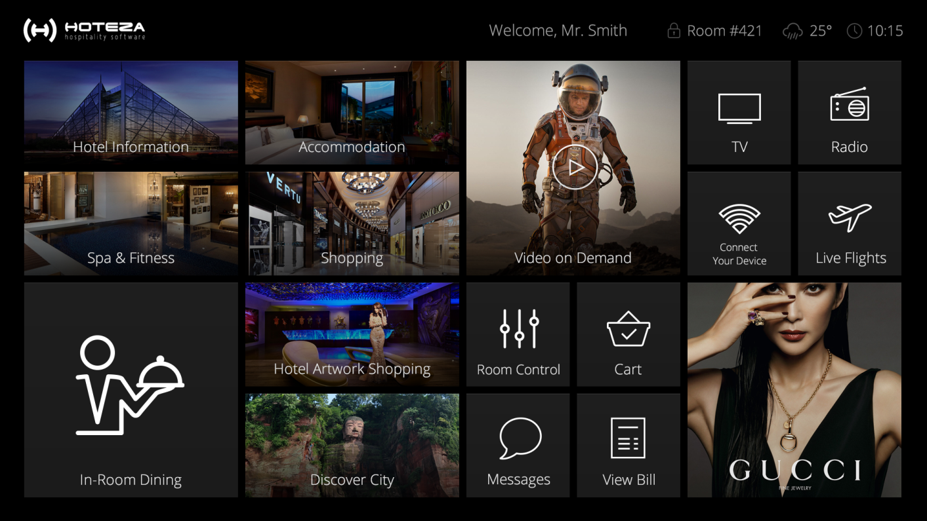

**Picture 5.** Hoteza TV regular design – Main screen

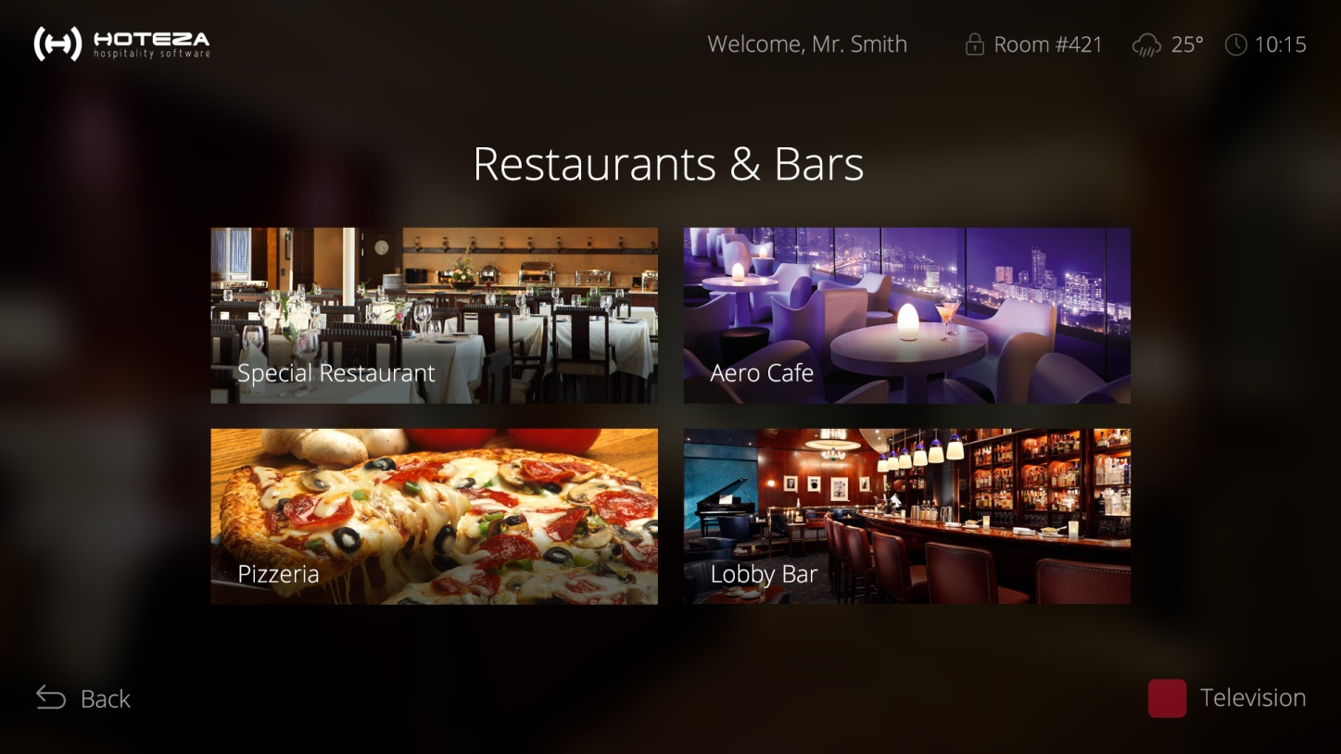

**Picture 6.** Hoteza TV regular design – Categories selection

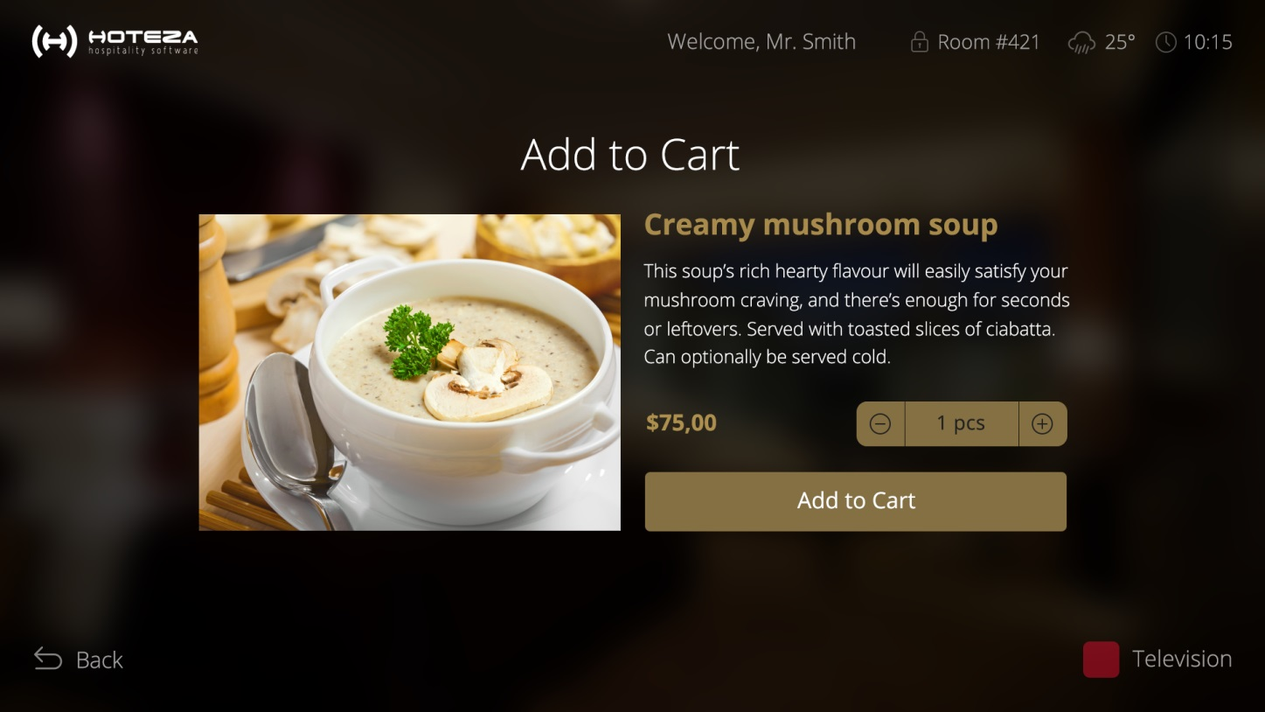

**Picture 7.** Hoteza TV regular design – in-room dining / shopping

**5. Hoteza References**

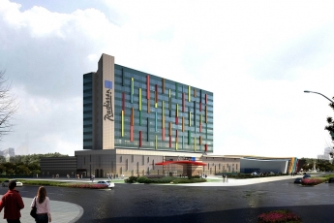 [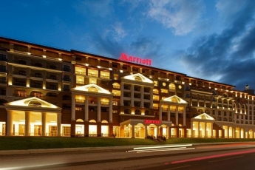](http://www.smarteq.ru/en/gallery/418) 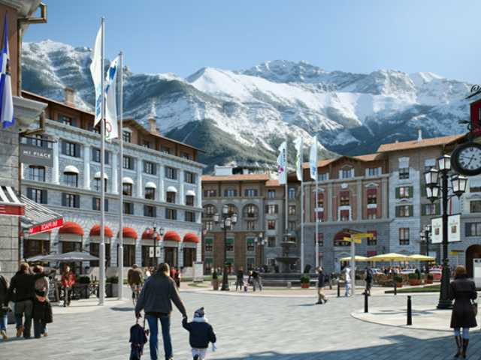

**Radisson Blu Chelyabinsk Sochi Marriott Krasnaya Polyana Gorki Grand Hotel**

*Chelyabinsk, Russia Sochi, Russia Sochi, Russia*

Hoteza TV / Hoteza HSIA Hoteza TV Hoteza TV

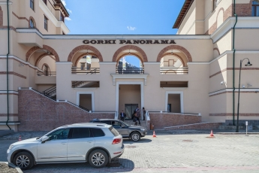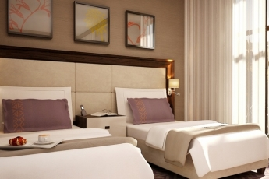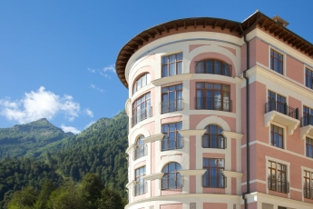

**Solis Sochi Hotels & Suites Dolina 960 Gorki Gorod Gorki Panorama Hotel**

*Sochi, Russia Sochi, Russia Sochi, Russia*

Hoteza TV Hoteza TV Hoteza TV

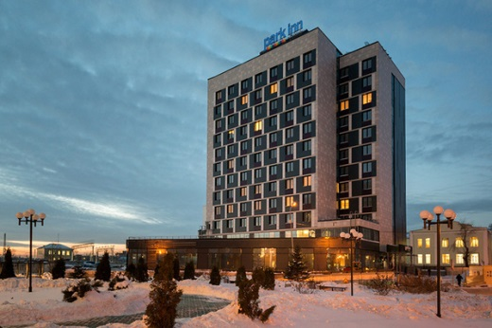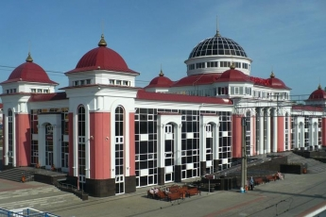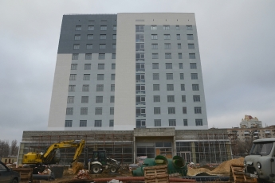

**Park Inn by Radisson Volgograd Park Inn by Radisson Novosibirsk Admiral Hotel Saransk**

*Volgograd, Russia Novosibirsk, Russia Saransk, Russia*

Hoteza TV / HSIA Hoteza TV / Hoteza HSIA Hoteza TV

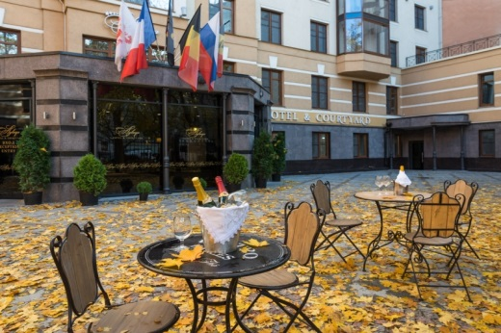 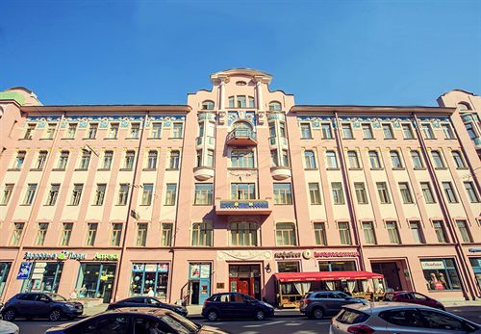 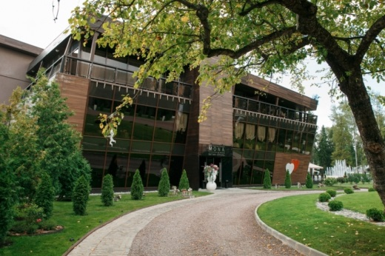

**Aglaya Hotel & Courtyard Akyan St.Petersburg Hotel Mona Boutique Hotel**

*St.Petersburg, Russia St.Petersburg, Russia Moscow, Russia*

Hoteza TV / Hoteza HSIA Hoteza TV Hoteza Mobile

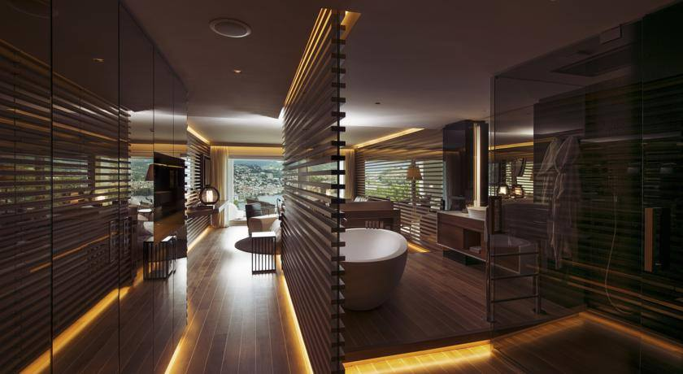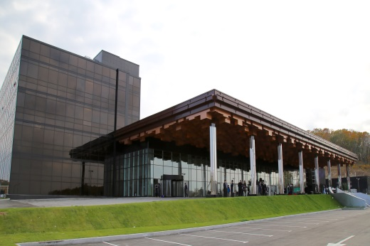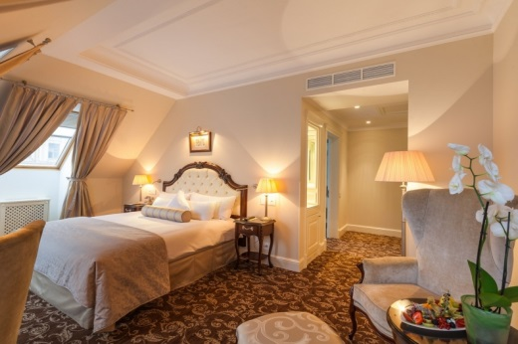

**The Hermitage Museum Hotel Tigre De Cristal Palace The View Lugano Hotel**

*St.Petersburg, Russia Vladivostok, Russia Lugano, Switzerland*

Hoteza TV / Hoteza Mobile Hoteza TV / Hoteza HotSign Hoteza HSIA

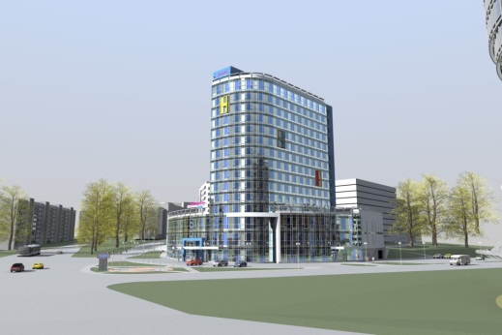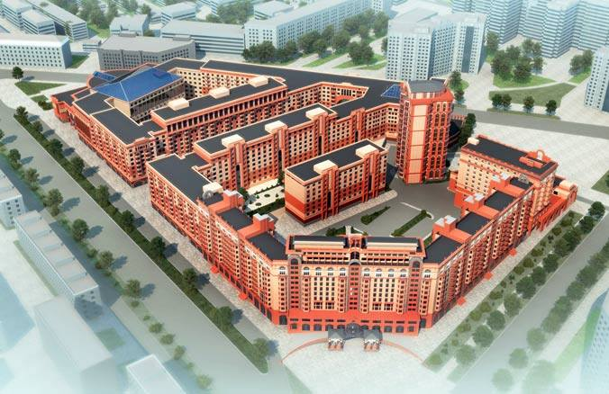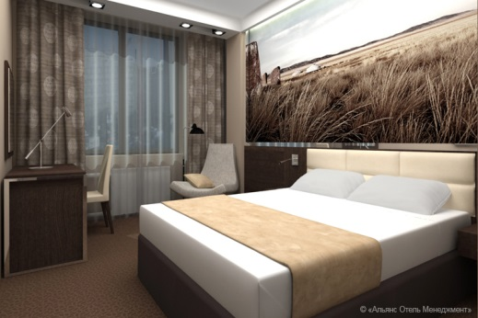

**Asia Business Hotel Abakan The Gorny University Hotel Hampton by Hilton Nizhny Novgorod**

*Abakan, Russia St.Petersburg, Russia Nizhny Novgorod, Russia*

Hoteza TV Hoteza TV / Hoteza HSIA Hoteza TV

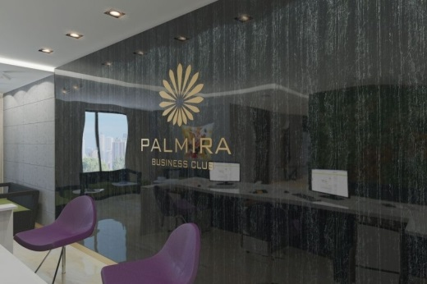 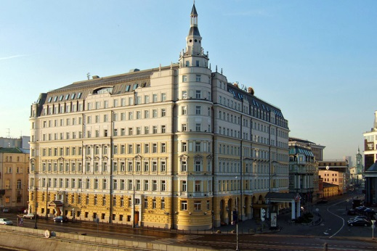 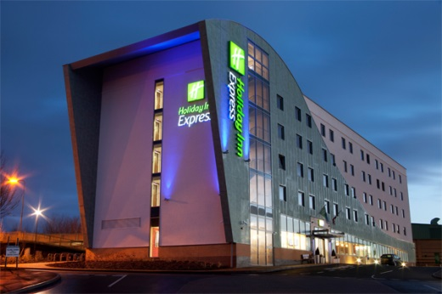

**Palmira Business Club Moscow Baltshug Kempinski Hotel Holiday Inn Express Voronezh**

*Moscow, Russia* *Moscow, Russia* *Voronezh, Russia*

Hoteza TV /Hoteza Mobile Hoteza HSIA Hoteza HSIA

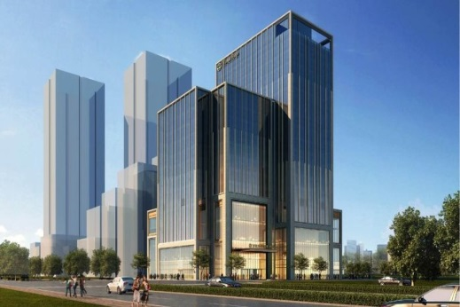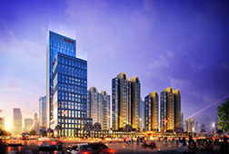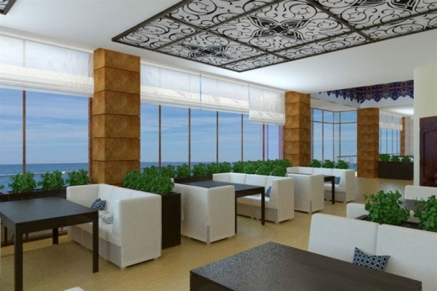

**Ribera Resort & Spa Wanda Reign Chengdu Hotel Wanda Reign Shanghai On The Bund**

*Evpatoria, Russia* *Chengdu, China* *Shanghai, China*

Hoteza TV Hoteza HotPad Hoteza HotPad

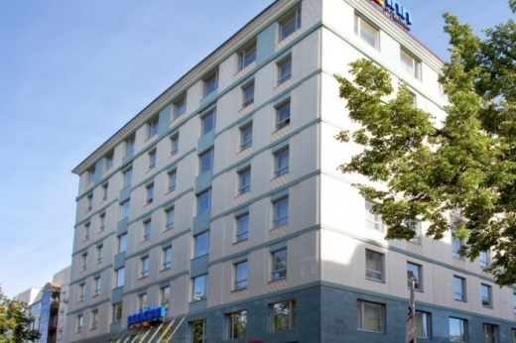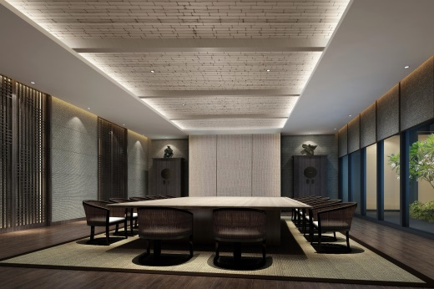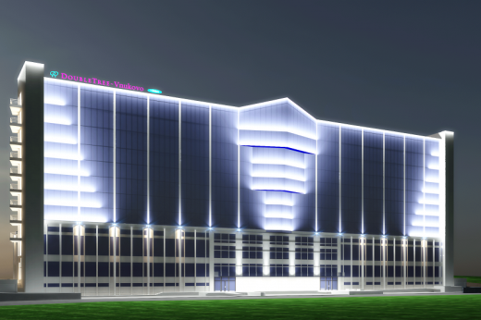

**DoubleTree by Hilton Vnukovo Wei Tianmu Lake Hotel Park Inn by Radisson Kazan**

*Moscow, Russia Hangzhou,China Kazan, Russia*

Hoteza TV Hoteza TV/HotPad/Mobile/HotSign Hoteza HSIA

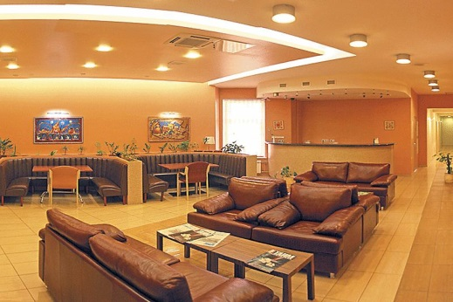 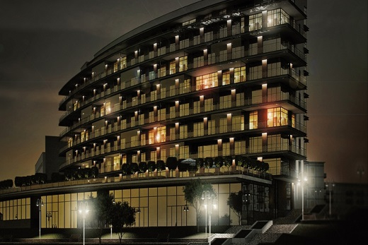 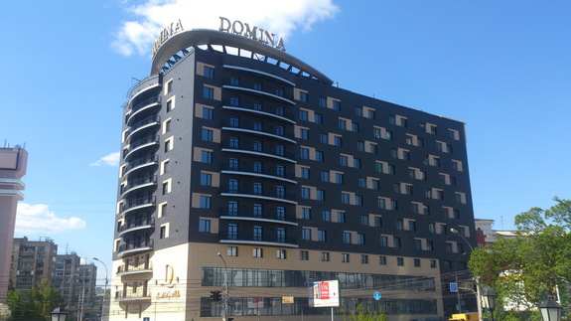

**5th Corner Hotel St.Petersburg Crystal House Apartments & Spa Domina Novosibirsk**

*St.Petersburg, Russia Kaliningrad, Russia Novosibirsk, Russia*

Hoteza TV / Hoteza HSIA Hoteza TV Hoteza TV

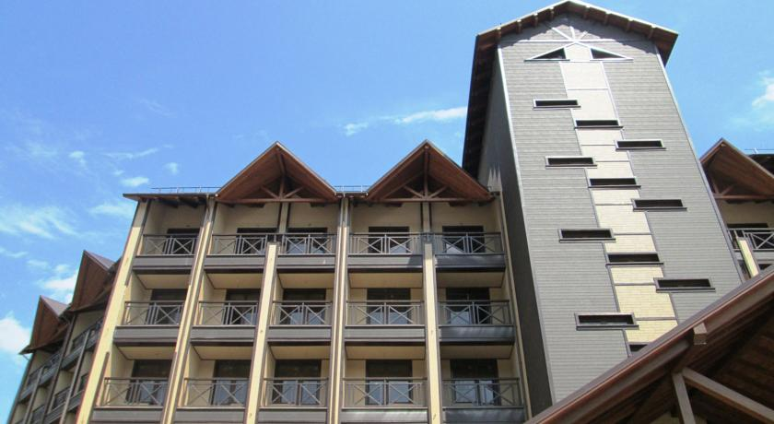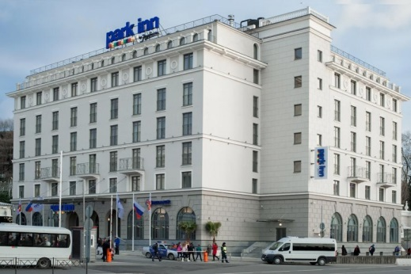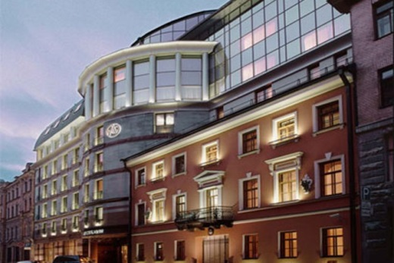

**Ambassador Hotel St.Petersburg Park Inn Sochi City Center Vertical Hotel**

*St.Petersburg, Russia Sochi, Russia Arkhyz, Russia*

Hoteza TV Hoteza TV / Hoteza HSIA Hoteza TV / Hoteza HSIA

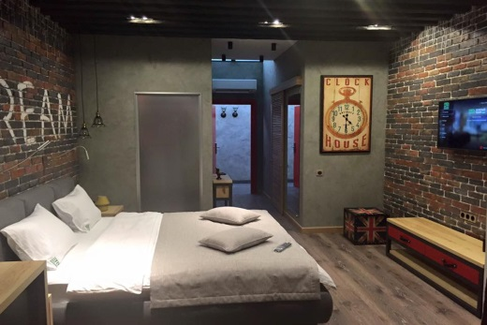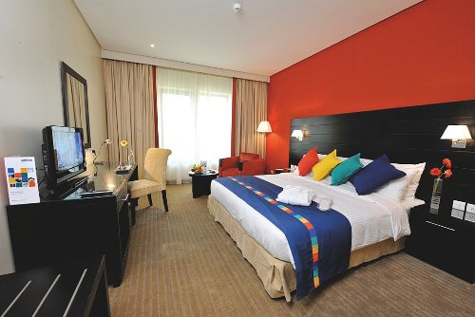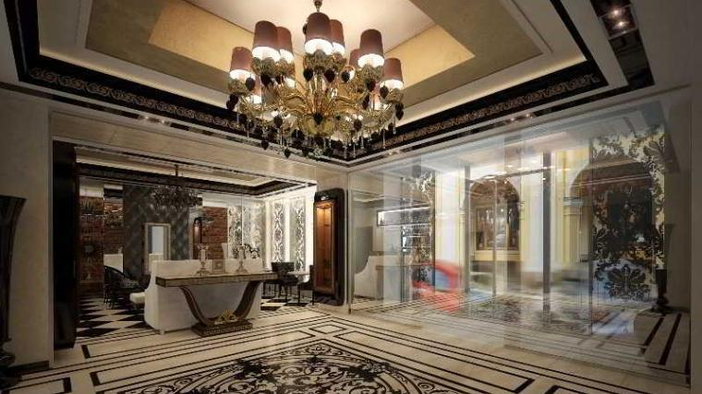

**Majestic Boutique Hotel Deluxe Park Inn by Radisson Astrakhan Green Theatre Boutique Hotel**

*St.Petersburg, Russia Astrakhan, Russia Simferopol, Russia*

Hoteza TV / Hoteza HSIA Hoteza HSIA Hoteza TV

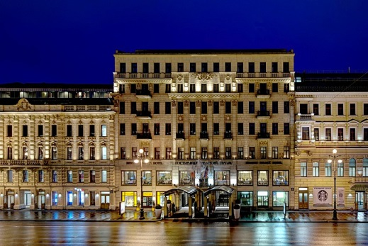 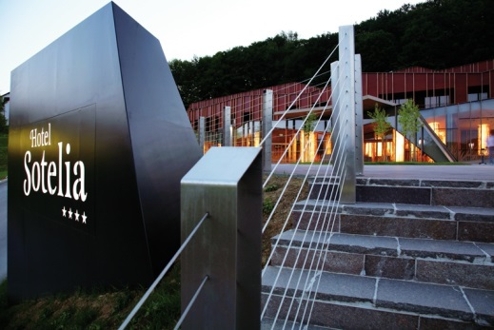 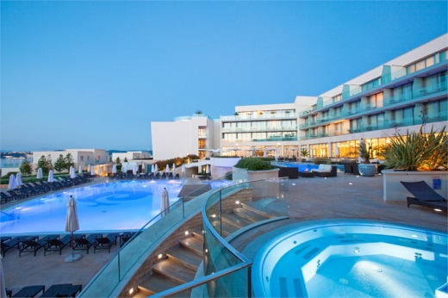

**Corinthia Hotel St.Petersburg Terme Olimia Hotel Sotelia Kempinski Hotel Adriatic Istria**

*St.Petersburg, Russia Podčetrtek, Slovenia Istria, Croatia*

Hoteza TV / Hoteza HSIA Hoteza TV / Hoteza Mobile Hoteza TV / Hoteza Mobile

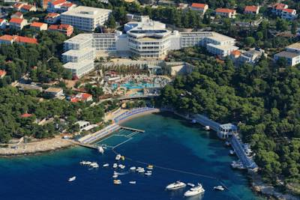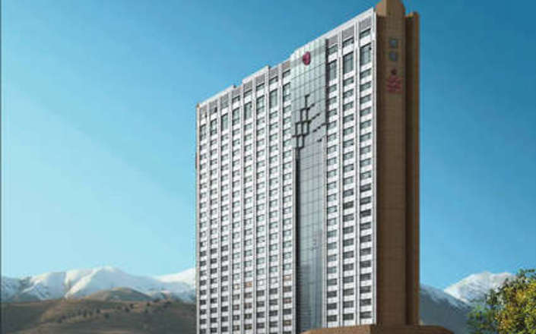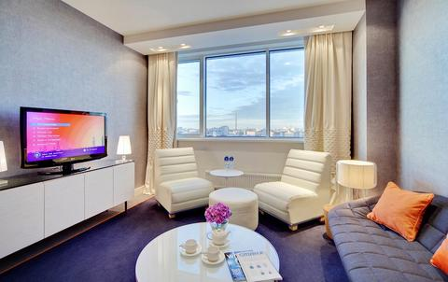

**Radisson Blu Belorusskaya Hotel Parsian Azadi Hotel Romana Beach Resort**

*Moscow, Russia Tehran, Iran Makarska, Croatia*

Hoteza HSIA Hoteza TV Hoteza Mobile

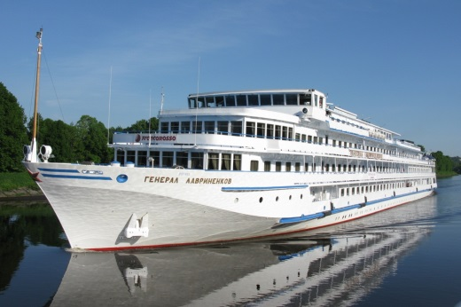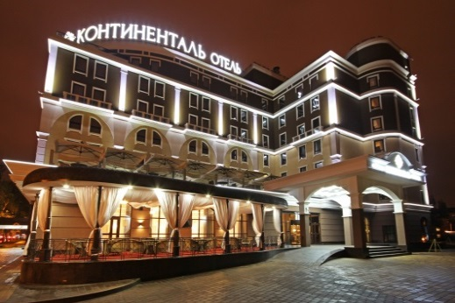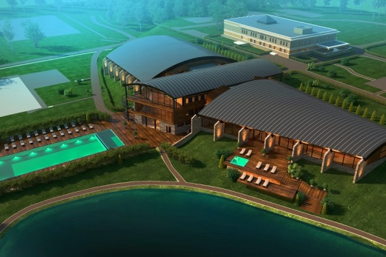

**Continental Hotel General Lavrinenkov M/S Luzhki Club**

*Belgorod, Russia Moscow, Russia Moscow, Russia*

Hoteza TV Hoteza TV / Hoteza HSIA Hoteza TV / Hoteza HSIA

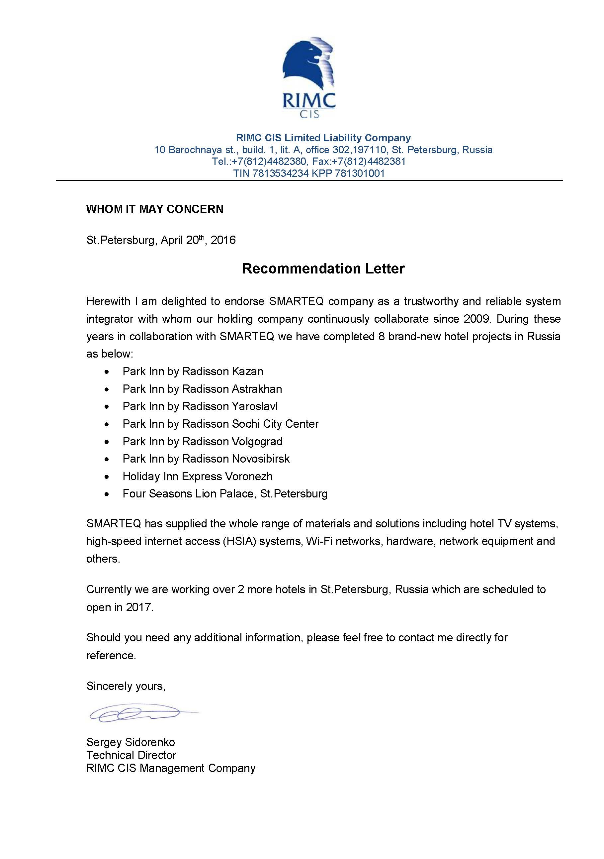**6. Customer Feedbacks**

